AIM: To configure and verify Dynamic Host Configuration Protocol (DHCP) in Cisco Packet Tracer for automatic IP address allocation.
TOOLS/SOFTWARES REQUIRED: Cisco Packet tracer
THEORY:
Dynamic Host Configuration Protocol (DHCP) is used to automatically assign IP addresses and other network settings like subnet mask and default gateway to devices in a network. It reduces manual work and avoids configuration errors.
DHCP follows a client-server model, where a DHCP server provides IP addresses to clients. When a device connects to the network, it requests an IP address from the server.
The working of DHCP is explained using the DORA process:
- Discover – Client sends a broadcast request to find DHCP server
- Offer – Server offers an available IP address
- Request – Client requests the offered IP
- Acknowledge – Server confirms and assigns the IP
DHCP uses UDP ports 67 (server) and 68 (client) for communication. The IP address is given for a limited time called a lease period.
In Cisco Packet Tracer, DHCP can be configured on a router or server to automatically assign IP addresses to multiple devices, making network management easier and efficient.

OUTPUT:
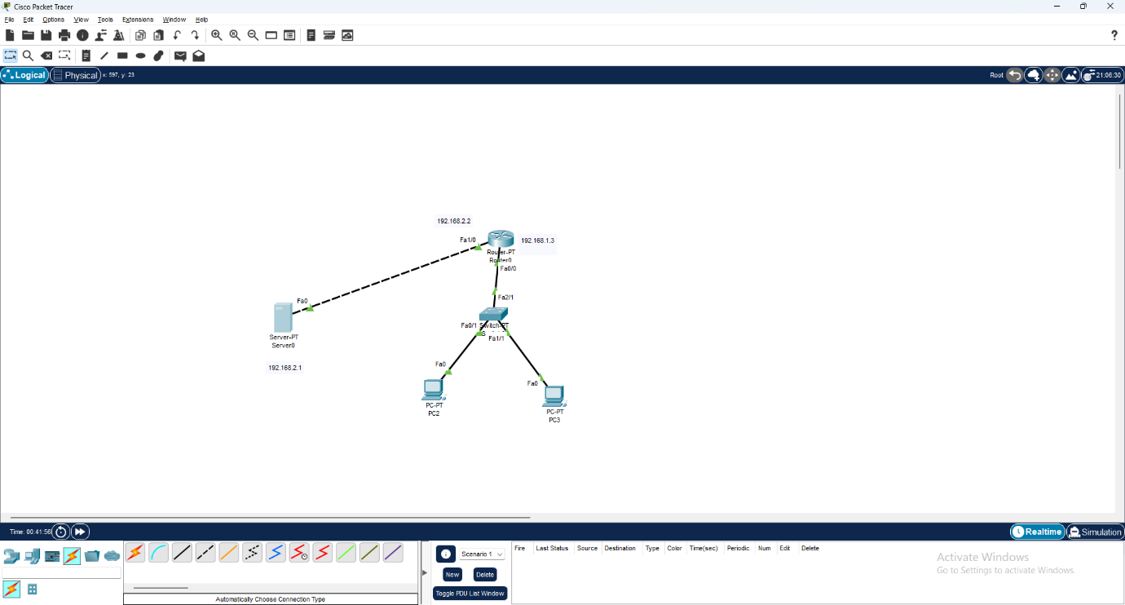
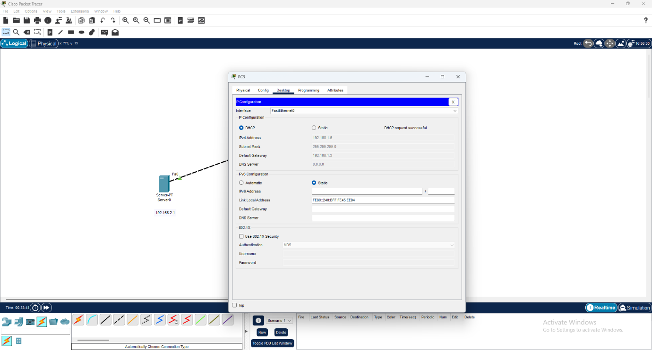
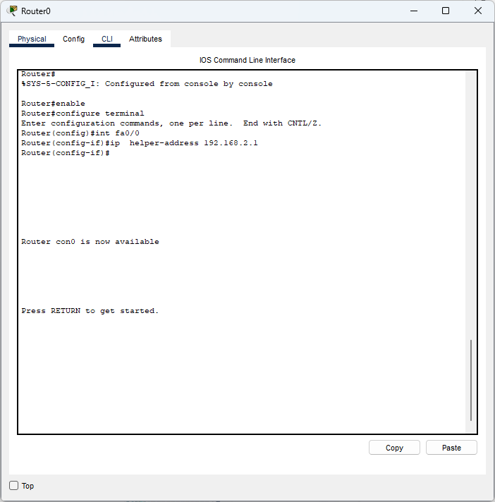

CONCLUSION:
Thus, DHCP was successfully configured and verified in Cisco Packet Tracer. The protocol automatically assigned IP addresses to client devices without manual configuration. This experiment demonstrated how DHCP simplifies network management, reduces errors, and ensures efficient IP address allocation in a network.

